Remembering a statesman: Hobgood's Avent succumbs
Written by Lance Martin

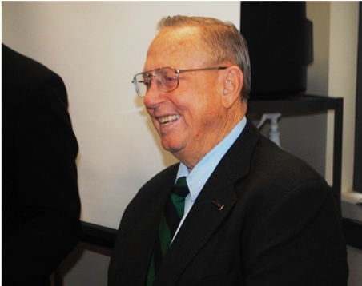
The morning of his Thursday afternoon death, the North Carolina Department of Transportation Board gave its unanimous endorsement of a resolution naming a 3.7 mile stretch of Highway 125 in honor of Frank V. Avent III.
Described by friends and colleagues as a friend of Halifax County and the town of Hobgood where he lived, Avent died that afternoon from a battle with cancer.
Avent had known about the road naming during the 30-day period between committee approval and full board approval, said Gus Tulloss, a DOT board member and friend of the 86-year-old former banker, who was a Nash County native. “He and his family were thrilled,” Tulloss said this morning. “He got to smell the roses for 30 days.”
Halifax County Board of Commissioners Chairman Vernon Bryant said at some point there will be a ceremony naming the stretch of highway from Hobgood to Douglas Hill Farm Road the Frank V. Avent III Highway.
Tulloss and Avent formed a friendship when Tulloss was working in his family’s tractor business in Rocky Mount and Avent was a loan officer at People’s Bank. “We developed a strong friendship. When he moved to Hobgood and I got on the DOT board the first person I ran into was Frank Avent. He was just so interested in Hobgood and what makes Halifax County work. He had lots of vision. You’ve got an incredible group there. They’re just wonderful to work with. Anytime Frank brought something, you knew there was no fluff. He’s just been a fun, wonderful guy.”
Close friend Halifax County Sheriff Wes Tripp said, “You can count true friends to be very few, those that you love and care for you, those that defend you in every boundary, when you’re at your lowest they are your source of strength. Me and Frank shared many good times together. I certainly many times have bent his ear in seeking much needed advice.”
Tripp called Avent a man “who had a heart of gold. He loved Hobgood and Halifax County. It goes much deeper than that, his love of Halifax County and helping basically every corner of Halifax County.”
Bryant said there were two things he always took away from Avent, one being his admonition that when “‘I get up each day I think of what I can do to make Halifax County a better place to live, work, and raise our families.’”
Then there was the oft-quoted working together works, which Aven took from former Halifax County Economic Development Director Ron Baker.
“It’s going to be mighty tough on all of us,” Bryant said of Avent’s demise. “Frank was a statesman. He was a leader in promoting public good. Frank loved Hobgood. He loved all of Halifax County. He was my friend and confidante. I frequently turned to him for counsel and advice.”
Avent served on many boards and commissions. His service included past chairman of the Halifax Community College Board of Trustees; the chair of the county economic development commission; vice chair of the Halifax Horizons Board and a member of the tourism and solar board.
“Frank has really impacted our community from Littleton to Hobgood,” Bryant said.
Bryant said he was thankful DOT saw fit to honor Avent. “The good part was Frank knew about it. He was very excited. Frank never wanted to be recognized. He was a great example of a public servant. He was a man loved by many in Halifax County, the entire Roanoke Valley and the state.”
Cathy Scott, executive director of the Halifax County Economic Development Commission said, “As chairman of the economic development commission, Frank Avent III believed strongly in Halifax County’s economic development potential. He had a passion for economic development and truly believed the only way to reach our true potential was by working together. His energy and passion will be missed.

