B-17 42-30278 / Sly Fox
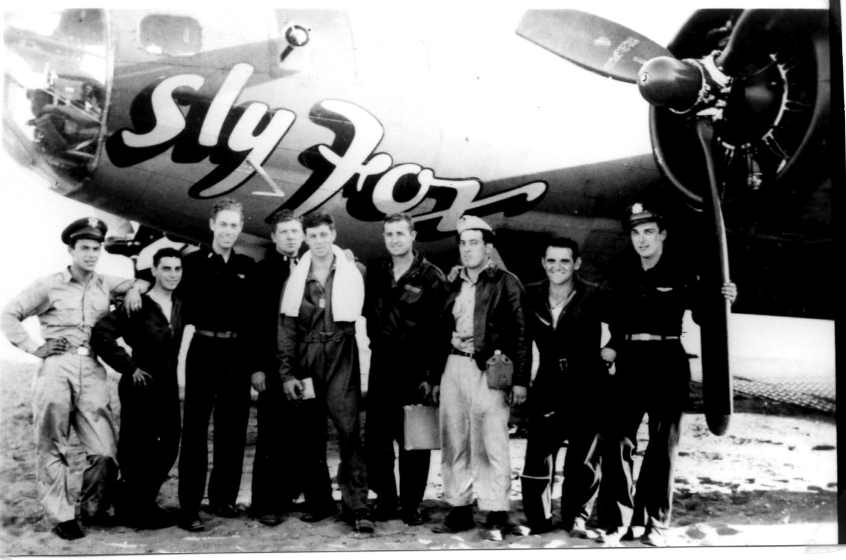zoom_in
Manufacturer:
Boeing
- Bomb Group:
- 100th Bomb Group
- Bomb Squadron:
- 418th Bomb Squadron
- RCL: SG-G, LD-R
Fate:
- Lost by enemy aircraft
- (06 March 1944)

History of
B-17 42-30278 / Sly Fox
Delivered Denver 8/5/43; Gore 9/5/43; Kearney 29/5/43; Dow Field 19/6/43; Assigned 550BS/385BG [SG-G] Gt Ashfield 20/6/43; transferred 418BS/100BG [LD-R] Thorpe Abbotts 9/43; Missing in Action Berlin 6/3/44 with Zeb Kendall, Co-pilot: Edwin Loughran, Navigator: Bill Thorpe, Bombardier: Cliff Gowen, Flight engineer/top turret gunner: Melvin Hickman, Radio Operator: Leman Tutor, Ball turret gunner: Reginaldo Aguila, Waist gunner: Ray Bridges, Waist gunner: Matt Avaon, Tail gunner: Vic Stoffregen (10 KIA); enemy aircraft, crashed Gross-Mimmelage, E of Quackenbruck, Ger. Missing Air Crew Report 3016. SLY FOX.
Source: Dave Osborne, B-17 Fortress Master Log*

B-17 42-30278 / Sly Fox Crew
Position | Rank | Name | Status | Note
P | 2LT | Zeb Kendall | KIA | -
CP | 2LT | Edwin J. Loughran | KIA | -
NAV | 2LT | William R. Thorpe | KIA | -
BOMB | 2LT | Clifford Gowen | KIA | -
ENG/TT | S/SGT | Melvin A Hickman | KIA | -
RO | S/SGT | Leman E. Tutor | KIA | -
BT | SGT | Reginaldo Aguila | KIA | -
WG | SGT | Matthew C. Aven | KIA | -
WG | SGT | Raymond L. Bridges | KIA | -
TG | SGT | Victor Stoffregen | KIA | -

The crash site was near Mimmelage and the crewmembers were first buried at the Cemetery in Quackenbrück!

