BURNS, John Ellis
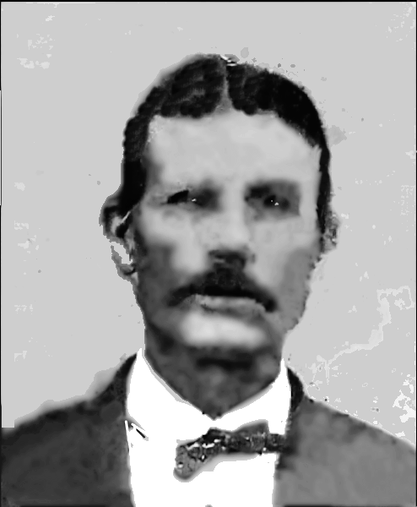

Name: BURNS, John Ellis, GG Granduncle

Birth Date: 1851
Birth Place: Mississippi
Death Date: 13 Jun 1906 Age: 55
Death Place: Roff, Pontotoc County, Oklahoma
Father: BURNS, Johnny (1815-1902)
Mother: PRICE, Sarah (~1820-1855)

Misc. Notes
Ada Evening News
June 13, 1906

ANOTHER SELF-CONFESSED MURDERER IN JAIL HERE

Delmar Dunsford shot and killed J. E. Burns near Roff Monday morning. After the shooting Dunsford went to Roff and surrendered to the deputy officer who brought him here on the morning train.

Dunsford, who is only eighteen years of age, has been married for a year. He heard Sunday that one of Burn's sons had been circulating stories" Of a slanderous nature about his wife. Sunday evening, he met the boy and gave him a severe beating, breaking two bones in his right hand in doing so.

Monday morning, being unable to work, owing to his injuries, he mounted a horse and started to carry dinner and water to work hands. In order to reach them be had to pass through a field where the boy's father was at work. He greeted him in the usual manner, but Burns caught his horse by the bridle and told him to dismount, he was going to fix him for whipping his son, Dunsford told Burns he had a broken hand and couldn't fight, but he dismounted.

He claims Burns bad a claw hammer in one hand and a wrench in the other and kept threatening him with these. Dunsford drew his gun and warned him to keep back but Burns kept advancing and shifted both weapons to one hand and reached for his hip pocket. Dunsford then fired twice and the second shot proved fatal.

The two men were neighbors and good friends and Dunsford expressed deep regret over the whole affair but claims he killed him in self defense

Spouses
--------------------------------------------------
1: HAMMOND, Nancy
Birth Date: 1856
Birth Place: Marion County, Mississippi
Memo: M
Death Date: 1887 Age: 31, Texas

