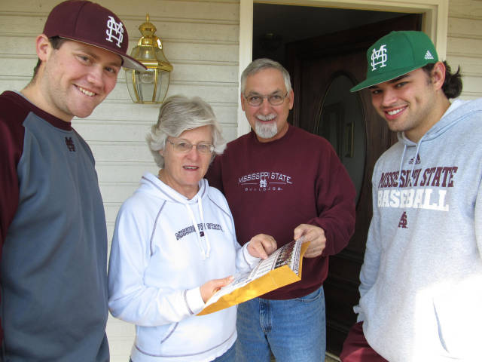
Diamond

Diamond Dog Delivery: State Players Deliver Baseball Season Tickets

STARKVILLE, Miss. - Ardent Bulldog fans Ken and Anna Hood have been Mississippi State baseball season ticket holders since well before the current Dudy Noble Field grandstand was opened in 1987. In addition to having season tickets in the Dudy Noble Field grandstand, they also have a trailer on the front row of MSU's popular left field lounge.
They are members of MSU Baseball's Foster Parent program and have followed the Bulldogs to the College World Series in Omaha, Neb., and on the road for SEC and NCAA Tournament competition. With a knock on the door of the Starkville home Saturday morning they experienced a first in their years of backing the Diamond Dogs: two members of the MSU team hand-delivered their 2013 baseball season tickets. Sophomore pitcher Trevor Fitts of Helena, Ala., and senior first baseman Trey Porter of Hurley, Miss., did the delivery honors this year.
"It was a great experience opening the door and having Trevor and Trey hand us our baseball season tickets," said Ken Hood. "It's exciting to have them deliver the tickets and it makes us all the more anxious to get the 2013 season started."
It's the fifth year that members of the MSU baseball team, divided into two-player teams, have delivered baseball season tickets to some of State's baseball patrons in the Starkville community. The team project was initiated in 2009 by MSU head baseball coach John Cohen, with hundreds of season tickets distributed personally by Diamond Dog players since the program's start.
"The ticket delivery program affords our players another great opportunity to connect directly with some of our great fans away from Dudy Noble Field," said Cohen, set to begin his fifth season as MSU skipper. "We have a great appreciation for the tremendous support our fans provide. This is just another way to say thank you face-to-face and help introduce our younger players to members of our fan base."

