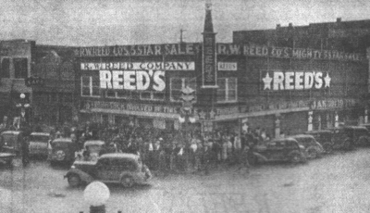

Historic Downtown Tupelo flagship store opened in 1905 as a general dry goods store. Founder, Robert Wylie Reed Sr., was an energetic, dynamic young man that always had “something going on.” Reed’s held America’s first “One Week Day & Night Sale” in the 1920’s, being open 24 hours a day for a week to drive business. Over the years Reed’s has expanded to currently wrapping around 3/4 of a city block. We are really a collection of 4 specialty stores under one roof: Men’s Women’s, Kids’, Gifts & Books.

