Abraham Lincoln and Sister Taught by Zachariah Riney
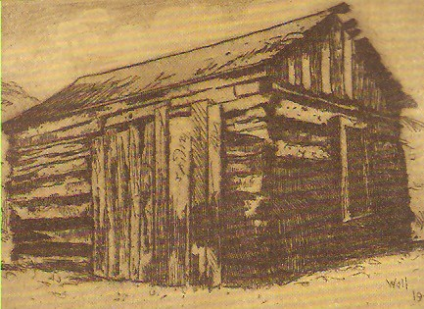
The drawing depicts the first school Sarah and Abraham Lincoln attended in Kentucky with Zachariah Riney as their teacher.
On June 10, 1806, Thomas Lincoln of Hardin County, Kentucky, traveled to the Washington County Courthouse to obtain a bond to marry Nancy Hanks. Two days later the wedding took place in Richard Berry’s cabin located close to Beechland in Washington County, Kentucky. Reverend Jesse Head, a minister in the Methodist Episcopal Church, performed the ceremony in the evening after a day of festivities.

The Lincolns settled in Elizabethtown. Their first home was a rustic cabin not far from the courthouse. and they celebrated the birth of their first child, Sarah, on February 10, 1807. In 1808 the Lincolns moved to the Sinking Spring Farm located on the south fork of Nolin Creek, around two and a half miles from Hodgenville, Kentucky. There a second child was born on February 12, 1809. This time the Lincolns had a boy and named him Abraham. In 1811 the Lincolns moved to the Knob Creek Farm. In 1812 a third child was born to the family, but Thomas died in infancy.
In 1815-1816 Sarah (who was often called Sally) and Abraham attended a log schoolhouse taught by Zachariah Riney and Caleb Hazel. In 1897 Susan Riney Yeager, Zachariah Riney's daughter, was interviewed by the Elizabethtown (KY) News. Here is a part of that interview:
Yes I remember Abe Lincoln well as a little bit of a fellow, she said it was what now is Larue County, but was then a part of Hardin County. Abe and I went to the same school. My father Zachariah Riney, was the teacher.
I can see the old school house now, the old lady continues with a far-away look in her eyes. It was built of rough logs, as all schoolhouses were in those days and mostly all of the dwelling houses, daubed with mud. The schoolhouse had no windows, but one log removed the length of the building served for light and ventilation. The floor was a dirt one, leveled and beaten solid. The benches consisted of logs split in the middle and place alongside the walls. There was just one bench made of plank supported by stumps. This the privilege of sitting upon it.
The old lady laughed as her memory called her back eighty long years and evidently the senses of her childhood were vividly presented to her mind. She continued... But you want to know about little Abe. He was then barely seven years old and I was ten. I remember his big sister bringing him to school the first day. Oh, she was fond of him, she also attended school there; and all day long, whether at lessons or at play, her careful eye was constantly watching him. She was a regular little mother to him. I have seen her on rainy days, or when the roads were muddy, carrying him in her arms to and from the school house. At playtime she would always insist that he play with her and the girls., telling him to keep away from the big boys, as they were likely to hurt him in their rough play. In those days quit a number of the scholars were full grown men.

