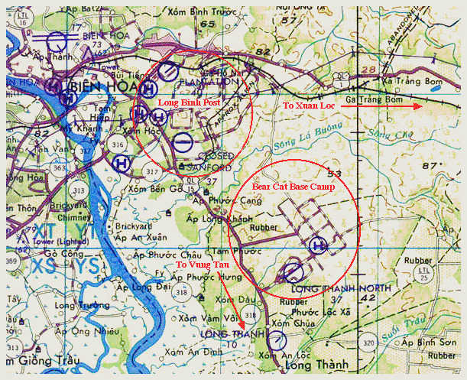
BEARCAT BASE CAMP – A mechanized unit rarely leaves its armored personnel carriers except for a few three-day hikes which are fondly recalled over a beer as "remember when we humped."
The recent mission of the 25th Division’s Charlie Company, 1st Battalion (Mech), 5th Infantry was one of those memorable jaunts. The objective was to check out some thick jungle terrain inaccessible by tracks.
The landing zone was a clearing in the jungle just large enough for one chopper to get in at a time.
"As we came down, I noticed piles of dirt in the midst of the green to our right," said Sergeant Norm Shirley, a Bobcat squad leader from Jamestown, N.D. "My thoughts were that we were going to get a greeting from Charlie."
The insertion went without incident, however, although indications were that two days earlier, about 20 enemy had dug in at that location.
The Bobcats regrouped and headed out on the first leg of their three-day walk. As the first day came and went, the mechmen adapted to the routine of living out of the infamous rucksack.
"I never was a Boy Scout, but I had a shelter up in no time," said Private First Class Fred Davis of Valdosta, Ga. "It must have been incentive stirred by threatening skies."
The tall grass became jungle and the jungle became high forest as the second day became into the third. There was still no trace of the enemy as the final grid square was covered.
"After three days of rain, I felt like a sponge," said Davis. "We met no enemy though, which wasn’t a big consolation.
"Walking wasn’t as bad as I expected," said Private First Class Bob Michaels of Berkley, Mich. "But as I approached the laager site, those tracks looked like heaven." Michael opened his track’s ice chest, pulled out a soda and took a good cold slug. "Yep," he said, "there’s no place like home."
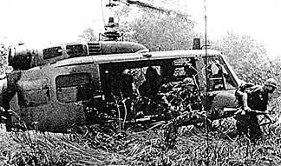
MOVING OUT – Carrying a shovel in one hand and an M-16 in the other, SFC Jerry Harris of Fort Campbell, Ky., a platoon sergeant with Charlie Company, 1st of the 5th, leads his squad out of a chopper and to cover.

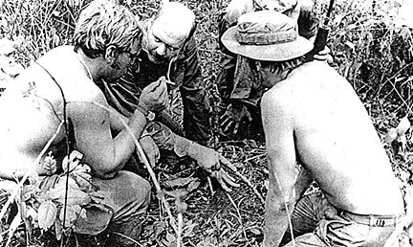
GETTING IT TOGETHER – Sergeant Frank Cossick of Coalpoint, Pa., Sergeant Norm Shirley of Jamestown, N.D., Sergeant Glenn Graft of Columbus, Ohio, and Sergeant First Class Jerry Harris huddle and sketch out in the mud positions for a night defensive position. Conference took place during an airmobile operation east of Xuan Loc.
Sergeant Harris was my platoon sergeant and the others were my squad leaders.

