Five local students selected for State Superintendent’s Student Advisory Council
- By JOHN H. WARD Monroe Journal
- Oct 21, 2020

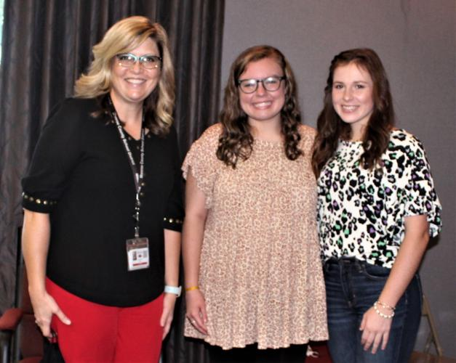

Hatley Attendance Center Principal Kristy Keeton, left, presented students Hannah Carson and Emma Thompson at the Monroe County School Board meeting on Oct. 13 as new members of the advisory council.
The Mississippi Department of Education (MDE) recently announced several new members of the State Superintendent’s Student Advisory Council. Of the 163 applicants selected, five are from Monroe County. India Fears is a student at Aberdeen High School, Hannah Hoang and Will McComb are students at Amory High School, and Hannah Carson and Emma Rose Thompson attend Hatley High School.
Selected students act as liaisons between the MDE and public school students from across the state. The advisory council includes high school juniors and seniors and first-year college students who serve as members for a term of two school years. The new members will join the more than 70 students who were selected in 2019.
According to Patrice Guilfoyle, MDE director of communications, the applicants wrote essays to enter their names in the competition that provided information about their backgrounds, accomplishments and experiences that would be of benefit to the advisory council.
Talking points for essays included what the applicant believes is the most important issue facing students in Mississippi, along with sharing a challenging experience he or she had or observed at school that made them realize they can improve Mississippi’s educational system.
“All entries were subjected to a review by a jury of educators and graded on a rubric. Scores of 50 out of a possible 60 points qualified the entrants to be inducted into the council,” Guilfoyle said.
Fears’ mission on the advisory council is to promote better education for schools such as Aberdeen.
“We need to attract more qualified staff with a mission to mentor,” she said. “I’m the first person to represent Aberdeen High School on the council.”
In addition to taking classes at Aberdeen High School, she also studies health sciences at the Monroe County Career and Technical Center and participates in AHS’ middle-college program at the Mississippi University for Women.
Amory Career and Technical Center engineering instructor Jennifer Hood served as the liaison to get Hoang and McComb to apply for placement on the advisory council.
“I saw the ad from [State Superintendent of Education] Dr. [Carey] Wright recruiting students. I immediately thought of Hannah [Hoang] and Will. I printed the applications, and they did the rest,” she said.
Hoang and McComb are involved in various extracurricular activities that have prepared them to take on the additional opportunity to be liaisons, themselves, between the MDE and local schools and communities.
“Our leadership positions pushed us to want to be involved,” Hoang said.
Both Hoang and McComb will advocate for more resources for rural schools.
“Their passion came through in their writing,” Hood said after reviewing their applications. “They will represent us well.”
Hoang hopes that through meeting people and having conversations that they can spark a change.
“The different experiences of people in other places in the state will benefit us, even though it’s going to be through Zoom meetings,” McComb said.
Hatley Attendance Center Principal Kristy Keeton is very pleased to have two students representing her school on the advisory council.
“What an honor Hannah and Emma Rose have received to be able to represent the students of Mississippi in order to lend Dr. Wright a student’s perspective on education,” Keeton said. “Hatley School could not be prouder of them.”
Carson will seek input on ways to make school more engaging for students, while Thompson’s heart is in helping disabled and disadvantaged students to maximize their potential.

