2017

“Is anyone here a potter?”, he asked in Spanish from his wheel. My husband pointed to me, and before I knew it, I was taking Azariel Santander’s place at his ‘torno’ in Trinidad, Cuba, about to throw a small bowl out of clay from the Escambray Mountains, while 25 people watched!!
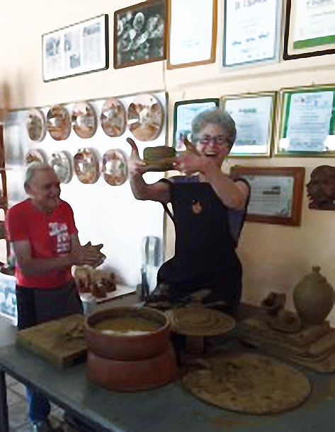

It was an amazing experience with one of Cuba’s best-known potters. What’s next??? He invited me and my potter-friends to come back and spend a week or two throwing and sharing with him and his family!! Who’s in???

