

Defense POW/MIA Accounting Agency
Our Nation's Promise

Service Member
CPL. JOE THOMAS AVANT

KOREAN WAR
UNITED STATES ARMY
Accounted For
09/10/2019
On September 10, 2019, the Defense POW/MIA Accounting Agency identified the remains of Corporal Joe Thomas Avant, missing from the Korean War. Corporal Avant entered the U.S. Army from Mississippi and served in the Heavy Mortar Company, 31st Infantry Regiment, 7th Infantry Division. His unit was a part of the 31st Regimental Combat Team (RCT-31) during the Battle of the Chosin Reservoir. CPL Avant was reported missing in action following Chinese Communist Forces counterattacks on November 30, 1950. He died following his disappearance, though specific details regarding his loss are unknown. In 2018, the North Korean government repatriated 55 boxes containing the remains of American service members lost during the Korean War. One box contained remains recovered from the east side of the Chosin Reservoir, which made an association with CPL Avant feasible. DPAA analysts used laboratory analysis and circumstantial evidence to identify CPL Avant from among these repatriated remains. Corporal Avant is memorialized on the Courts of the Missing at the National Memorial Cemetery of the Pacific. His name is also inscribed on the Korean War Veterans Memorial Wall in Washington, DC, which was updated in 2022 to include the names of the fallen.
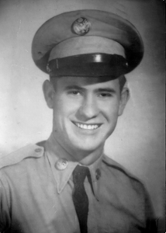

CPL. JOE THOMAS AVANT
- Unit
Heavy Mortar Company, 31st infantry Regiment, 7th Infantry Division
- Historical Country of Loss
North Korea
- Current Country of Loss
KOREA, NORTH
- Home of Record* MS

