Women Who Run the Show: Frances Hill of Urban Stages
by Adrienne Onofri Mar. 26, 2009
Fourth in a Women’s History Month series on female artistic directors
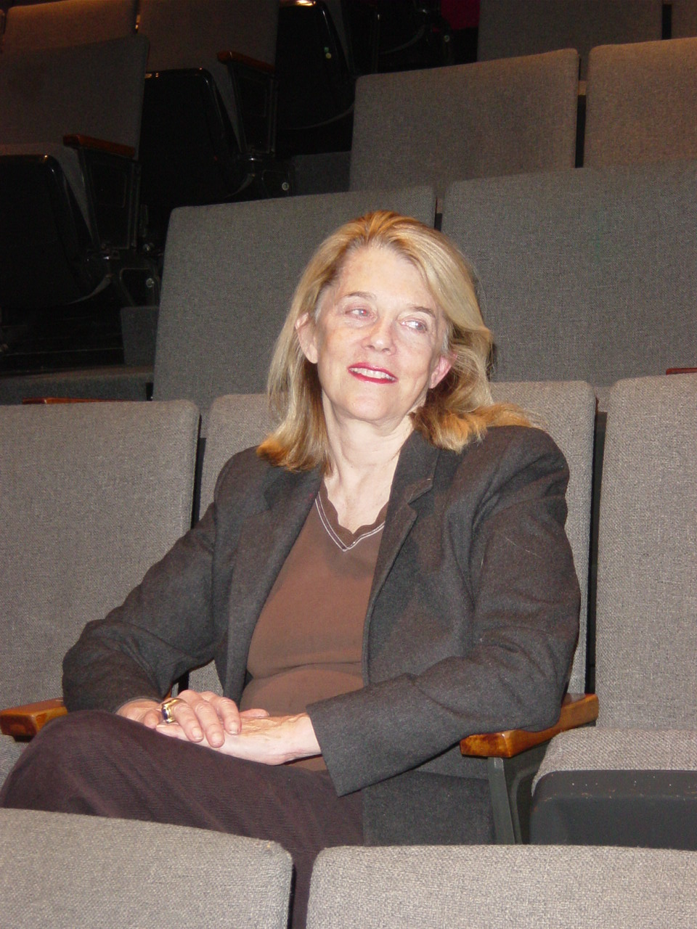
Gangway, world, get off of our runway...women, according to Urban Stages artistic director Frances Hill, are set for a massive breakthrough in theater. “I think there’s going to be a great women’s revolution,” says Hill. “When you look at the women whose plays are out there now, they’re of tremendous substance and they’re all interesting and they’re taking a little risk. Women have a lot to say. I think they’re in a much better place than ever before as far as what they’re contributing to drama. They’re going to take over, believe me.”

Hill to promote artists—the goal was showcasing newer playwrights, male and female. “I look for the play first,” she says, “but I love if there’s a woman’s voice. What I want to do for any playwright is show their work and have it move. I mean, we’re 75 seats. I want more people to see it. The last six or seven plays we’ve done have been published, and that makes me feel good because I know that they’ll be out there.”

The company has produced plenty of plays by men, but some of its biggest successes came from women. Eisa Davis’ Bulrusher, which had its world premiere at Urban Stages in 2006, was a finalist for the Pulitzer Prize. Chungmi Kim’s Comfort Women, developed by Urban Stages, was published in New Playwrights: The Best Plays of 2005 and has been produced internationally. 27 Rue de Fleurus, a musical about Gertrude Stein and Alice B. Toklas cowritten by Lisa Koch (with Ted Sod), had an extended run last spring.
Urban Stages’ history also includes several acclaimed plays about women that were written by men, among them 2005’s Marion Bridge, which told of three sisters returning home to tend to their dying mother. The author was Daniel McIvor, and Hill says his “unbelievably sensitive” work proves “you can’t say a man cannot write a woman’s story—or a woman cannot write a man’s story.” (She’s workshopped McIvor’s new play His Greatness, about Tennessee Williams’ final days, and hopes to produce it in the future.) Another woman-oriented but male-written hit was John Picardi’s WWII homefront dramedy The Sweepers, about three Italian-American wives; it was produced at Capital Rep in Albany and Boston’s Huntington Theatre after its 2002 Urban Stages run.

Last fall’s New Play Festival at Urban Stages was dominated by women writers and directors. Trezana Beverley (of For Colored Girls... fame) directed Warriors Don’t Cry, Davis’ account of the 1957 desegregation of Central High School in Little Rock. Brigitte Vielieu-Davis directed both her own play about Frida Kahlo, Frida Liberada, and Adriana Rogers’ Rosie, a solo show about Rosie the Riveter. Jo Tanner wrote and performed a biography of pioneering African-American businesswoman Madam C.J. Walker, and Shana Gold directed At the Pole.

Most of those plays are history-based because they originated in Urban Stages’ community outreach that presents original plays in NYC libraries and schools. The company also develops new work in readings (some open to the public) and workshops. Its outreach program was formed when the theater itself was still known as Playwrights Preview Productions. “We started this outreach in libraries and schools and we called that Urban Stages, so finally we decided to put the whole theater under Urban Stages,” Hill says, explaining that the cumbersome original name reflected her mission when she established the company in 1984: “There were so many small theaters at that time that were for the actors—to get them to be shown. I said: You know what? There’s no play unless there’s writers. This was before people were doing much development or readings or any of that kind of thing. So we started it as Playwrights Preview Productions—we were previewing playwrights.”

Under her initial plans for the theater, every production would be a double bill. “We thought we’d put together known and unknown playwrights, like we would take a short play of Arthur Kopit and do it as a curtain riser,” she says. The troupe’s first effort featured a one-act by Hill herself, Our Bench, and one-acts by Leonard Melfi and Israel Horovitz. But before long, “we sort of ran out of the short plays [by established playwrights],” she recounts. “We also found out the press didn’t like Playwrights Preview Productions because they wouldn’t do ‘PPP’ [in print] and the full name was so long.”

Urban Stages gained considerable stability in the early ’90s when it moved into its own theater on W. 30th St. just off 8th Ave. “We were running all around town, in all kinds of theaters, until we got this space,” says Hill. She leased the former Miranda Theater and renovated it with funding from the Peter Jay Sharp Foundation. The space is composed of the theater and lobby on street level and a rehearsal studio, scene shop, storeroom and dressing rooms on two other floors. The theater is occasionally rented out to other producers.

Almost from the start, Hill’s had an adjunct mission for her company. “Very early I got interested in plays that brought out the cross-cultures in New York, where we live,” she says. “We discover, develop and produce plays by multiethnic playwrights that speak to the whole of society.” Bulrusher, for example, deals with a black orphan growing up in an otherwise all-white California town. Comfort Women’s title characters are Korean women enslaved as prostitutes by the Japanese army during World War II. Guillermo Reyes’ Men on the Verge of a His-Panic Breakdown, which Urban Stages premiered in 1997, won an Outer Critics Circle Award for Felix Pire’s portrayal of six Cuban-American homosexuals.

Hill directed Comfort Women and The Sweepers, as well as Picardi’s 2004 follow-up to Sweepers, Seven Rabbits on a Pole, and the more recent 27 Rue de Fleurus and Apostasy. She also directed one of the earliest Urban Stages shows to garner attention, Chili Queen, a mid-’80s comedy by serious PBS newsman Jim Lehrer. Hill has done some writing too, but the San Francisco native got into theater as an actress. “As a little girl, I always put on plays,” Hill recalls of growing up in the Fresno area. “My mother used to say, ‘When are you going to get tired of doing this?’” After graduating from Berkeley, she pursued acting in California, got married and had three children.

She moved to New York following her divorce; her children were about 3, 5 and 8 at the time. “As a single mom, it was hard to be gone at night,” says Hill. Though she was performing less, she stayed involved in theater, writing scripts and keeping in touch with theater friends. Mutual admiration led to talk of producing led to somebody suggesting they found a theater—and Urban Stages was born. “Then something inside of me just sort of turned off as far as acting is concerned. I was more creatively satisfied through working with playwrights, directing, running this theater,” says Hill, who is now remarried and stepmother to an actor, David Barlow.

For more than a decade, she worked with T.L. Reilly as her producing director. He moved to Mexico about four years ago. (Reilly’s predecessor was Maggie Mancinelli-Cahill, who now runs Capital Rep and remains a close friend of Hill’s.) Last September, another Urban Stages longtimer, Sonia Kozlova, stepped down as managing director after eight years to pursue her MFA at Columbia. She was succeeded by Lauren Schmiedel, and currently everyone else on the four-person staff is female too. But Hill doesn’t believe that necessarily affects how the theater is run: “I think it depends on the size of the theater, it depends on the scope of their mission...I don’t know. I would say everybody’s personality and artistic goals [matter] more.”

As far as whether some kind of bias against women exists in the business and production of theater, Hill says, “I’m sure there is, but I don’t even think about it. I don’t have time to have a chip on my shoulder from worrying about it. I just believe in what I do and push forward. If you stop complaining and just get out and do it, present it, you’re going to be ahead.”

She adds, “I never thought being a woman was restricting to me—ever, in anything.” Theater in particular seemed pretty egalitarian to her. “I always thought they had to have women in the theater because there are women’s parts. The other good thing about the theater is you could be any age, because you need all ages [for characters],” she says. “Men have had a lot more years—Shakespeare, Molière, all of these classical playwrights [when] women weren’t really allowed to [write professionally].

“Wendy Wasserstein broke a great barrier for women,” Hill continues. “She wrote entertaining plays that could be loved by all audiences, and that’s what we need. We have to get a whole foundation of women writers. It’s going to be something that comes gradually and everybody will say ‘Hey, that’s good!’ and not because it’s a woman.” She mentions Lynn Nottage and Sarah Ruhl among those on the front lines of this “revolution.” (Three and a half years ago, Nottage, Ruhl and Theresa Rebeck were pictured on the cover of an issue of American Theatre about the most produced plays in America.)

This season, economic limitations may be trumping any concerns over women’s representation. “We’re trying to be as creative as we can in these times and still be able to produce, still be able to pay salaries,” Hill says. “The institutions like the DCA [NYC’s Department of Cultural Affairs] and the New York State Council [on the Arts] all have told us, ‘We’re pulling back, we’re pulling back, we’re pulling back.’ So you learn how to make other things happen. It’s looking at your numbers and seeing what you can do—okay, we can’t do it this way, but we’ll be more imaginative and do it this way, which isn’t going to cost as much money.”

For financial reasons, Urban Stages canceled its original plans for 2008-09 (its 25th anniversary) to revive The Oxford Roof Climbers Rebellion, Stephen Massicotte’s play about an episode in T.E. Lawrence’s life that was well received when it debuted at Urban Stages in fall 2007, and to give Jerusalem, a Seth Greenland comedy about a Jewish-Gentile marriage, its NYC premiere. It has postponed Jerusalem until next season, and now is in the midst of a Retrospective Reading Series, presenting staged readings of some of its greatest hits—with original cast members—each followed by a talkback with actors and playwright. The Monday-night series kicked off March 9; its remaining schedule: The Sweepers on March 30; Coyote on a Fence, with its original Drama Desk-nominated star Paul Sparks, April 13; and Bulrusher, with Eisa Davis, April 20. Admission is free, as it was for the New Play Festival.
Hill already is looking forward to Urban Stages’ next summer theater camp. Launched in 2005 for children ages 10 to 14, the camp features daily classes in various theater arts and skills taught by professional artists and culminates in a show written, performed, designed and produced by the campers. “I love watching these kids and what they create and how their lives change in five weeks,” says Hill, the grandmother of two elementary schoolers. Urban Stages also produces new plays for family audiences during school holidays.
In general, Hill is feeling very optimistic about theater in New York. “It’s amazing the number of good plays that come through now,” she remarks, noting that she had expected the opposite—a lot of subpar work—once everybody had a computer and it was easier for them to get their plays on paper. “The caliber is so much higher than it was maybe five or six years ago. I don’t know if that means there are more graduate schools that people are going to or there are more workshops or what it is. I feel badly that there is good work out there and I can’t do it all.”
Success in this business, according to Hill, ultimately doesn’t come down to dollars and cents. “You don’t survive if you’re all out there to get your name in print and have a hit show. It’s not about that. It’s about the process. It’s about giving to the stage in various forms. I’m very happy to have a really wonderful staff that is dedicated to the love of theater and the arts and working in this field. That is how you survive.
“I’ve loved what I’m doing,” she adds. “It’s never boring, because there’s always something new to create. Theater is very important—to people that watch it, people that perform it, people that produce it. It’s a communal art, and I guess my love for it is the reason I’m still here.”

