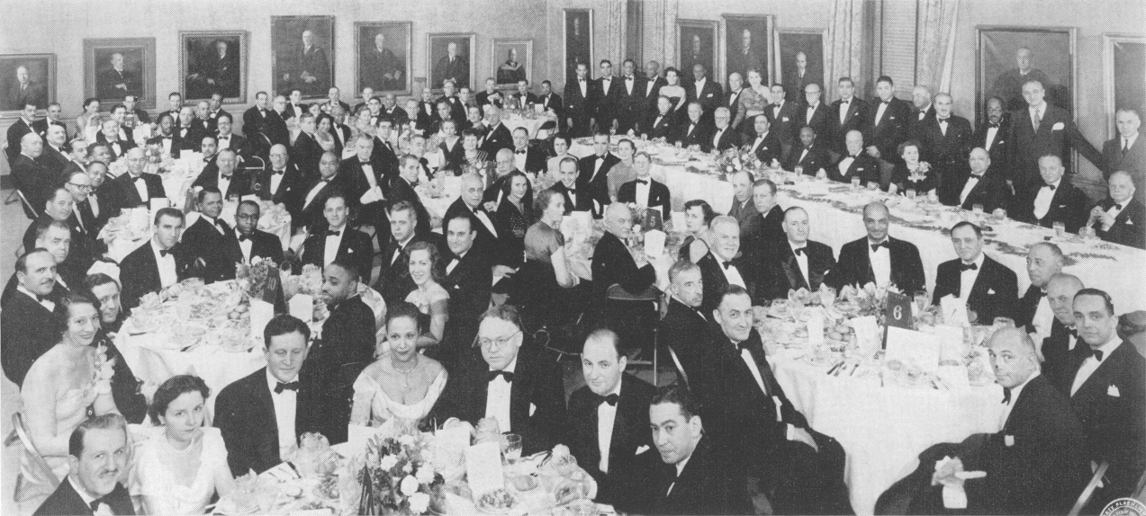

THE HENRY WISDOM CAVE TESTIMONIAL DINNER

given by the Harlem Surgical Society in the President's Room of the New York Academy of Medicine,

February 7, 1?31.

Speakers' table, 1. to r.: **Do. AARON PRIGOT,** vice-president, Harlem Surgical Society: **DR. KENNETH M.** LEwis, president, Medical Society of the County of New York ; OR. hit mls u **BARC** LAv **PARSONS,** president, New York Academy of Medicine ; **DR. W. MONTAGUE** COBB, professor of anatomy, Howard University; DR. Aubré deL Maynard, president, the Harlem Surgical Society; Dn. **HENRY** W. Cave, president, American College of Surgeons; MRS. **HENRY W. CAVE; DR.** Low Is **T. WRIGHT,** director, Department of Surgery, Harlem Hospital; DR. J. William Hinton, professor of surgery, Post Graduate Medical School, New York University; and MR. FALTER WHITE, executive secretary, National Association for the Advancement of Colored People.





Vol. 43, No. â

The Henry Wisdom Cove **Testimonial** Dinner

HE President's Room of The New York W Academy of Medicine was the scene of a historic occasion on the evening of February 7, 193 1. At this time the Harlem Surgical Society was host at a dinner in honor of Dr. Henry Wisdom Cave, president of the American College of Surgeons. The testimonial was in recognition of Dr. Cave's long continued efforts toward the elimination of racial barriers to admission to the College which have finally been crowned with complete success.

There were addresses by Dr. Aubré de L. May- nard, president, Harlem Surgical Society; Dr. Louis T. Wright, director of Surgery, Harlem Hospital; Mr. Walter White, executive secretary, National Association for the Advancement of Colored People; Dr. W. Montague Cobb, professor of anatomy, Howard University Medical School, and Dr. J. William Hinton, professor of surgery, Post Graduate Medical School of New York

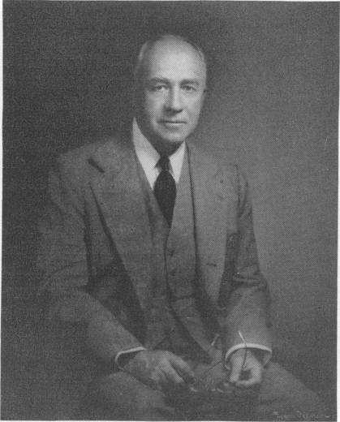

DR. HENRY WISDOM CAVE,

President, American College of Surgeons

University. A handsome scroll and an engraved silver tray were presented Dr. Cave by Dr. Aaron Prigot, vice president, Harlem Surgical Society. Dr. Cave responded with inspiring remarks.

Many of the nation's outstand ing medical lead- ers were among the distinguished guests assembled. As the photograph of the dinner shows, racial distinctions in the assemblage were conspicuous by their absence.

Excerpts from the addresses are here reproduced.

Toastmaster R. Maynard: As President of the Harlem Surgical Society, and on their behalf, I bid you hearty welcome. This occasion is both auspicious and historic. We have come together in good fellowship and because of great esteem, to pay homage to one of the most distinguished members of the medical profession, a man whom, for many years, we have known as a good and staunch friend.

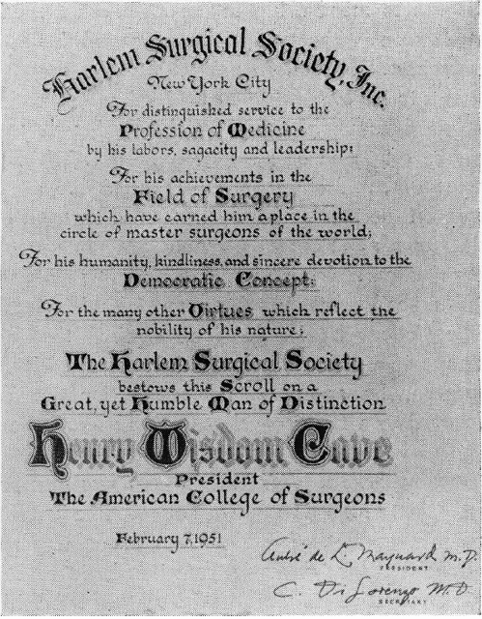

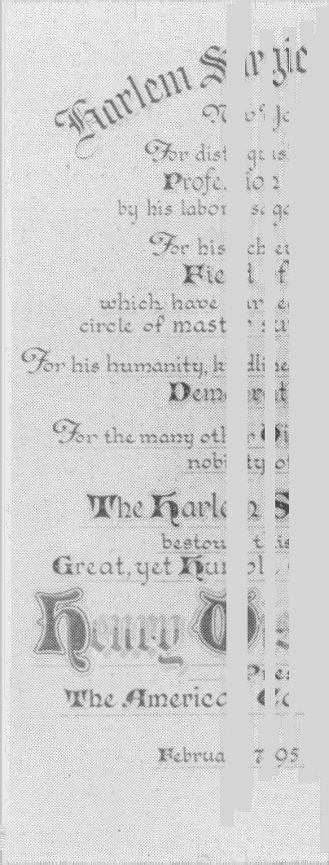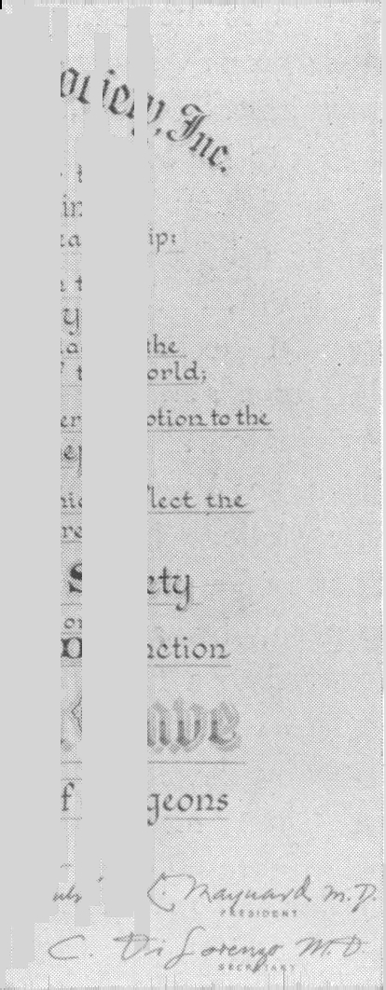

The scroll presented to Dr. Cave

19c **JOURNAL OF THE NATIONAL MEDICAL** ASSOCIATION

In this gravest period of our country's defense, the concept of democracy has been challenged as a fatuous and puerile idea, and the practice of democracy in these United States has been im- pugned before the world for its inequities. The American dilemma, with its unhappy reality of racial injustices has been employed with corroding effect on our domestic structure in the creation of dissensions. It has been rather devastatingly ex- ploited abroad to impair, through suspicion and doubt, the integrity of our world leadership.

We are persuaded, however, that despite its

obvious imperfections in attainment, democracy is the code of freedom and human dignity, that a large and influential body of Americans of good will is determined to translate this code into action, to establish democracy as a vibrant, dynamic pattern of life, dedicated to the interests of all its citizens, and giving to them in all its ramifications equal treatment, equal opportunity, and justice.

It is fitting, therefore, that by this public testimonial, also a reaffirmation of faith, we honor this man of goodwill who, in his phase of endeavor consummated the democratic ideal; for it was Doctor Henry W. Cave who initiated and pursued steadfastly efforts to admit the qualified Negro surgeon to membership in the American College of Surgeons without regard to color, and this as a commitment of College policy.

It is to his everlasting credit that by the exercise of good common sense, patience and tact, and by the contagion of his own convictions, he was able to break down a previously intractable resistance on the part of an unenlightened segment of the College and open the channels of understanding, justice, and fair play.

The end result has been mutually beneficial. The College by its decision, acquired the full stature of a democratic institution, and the Negro surgeon, by approval and certification, moved forward to a fuller development and recognition. The Harlem Surgical Society was founded in 1937 by Dr. Louis T. Wright, and was incorporated in 1944. It has grown from a mere handful of men to a membership of over one hundred physicians. As presently constituted, it reflects the integrative pattern of the staff membership of Harlem Hospital, white, colored, gentile, Jew. It has been vigorous in its stimulation of study,

investigation and research. It has brought before its membership some of the most distinguished figures of the profession and has at all times maintained the strictest ethical and professional standards.

It is to this body that Dr. Cave gave bountifully of his talents, his knowledge, his counsel. For this we have all been profoundly grateful. He has been our very great friend, and we have felt as Polonius did about friendship in his advice to Laertes:

”Those friends thou hast, and their adoption tried,

Grapple them to thy soul with hoops of steel.”

**DR. Louis T.** **WRIGHT:** Itis a pleasure and a privilege to be with you here this evening and to join with the Harlem Surgical Society in paying tribute to our distinguished guest **of honor,** Dr. Cave.

I do not need to go at this time into the subject of his eminence as a surgeon, scientist, or as a leading citizen. His achievements speak more eloquently in this respect than I could ever hope to do.

Perhaps a few words about the Harlem Surgical Society would not be amiss. This Society was organized some years ago to aid the professional development of its members, the majority of whom practice in the Harlem area. Since it was founded, the Society has served as a scientific forum before which its members could present the results of their work in surgery, and u a place where each member could participate freely in all discussions. It has encouraged study, on the part of every member, of the newer changes in surgical thought. It has stimulated original work among its member- ship.

I know personally that its members have sacrificed time, energy and money to improve them- selves and to raise surgical standards. Finally, the Society has served to make the membership conscious of its responsibility to the large community of citizens which it serves. If the Society has done this, and I feel sincerely that it has, it has more than justified its existence.

It has been a small society and it will always be one. At the time of its organization there was no surgical society to which the majority of its members could belong. Though originally it was

VoL. 43, No. 3 *Henry Wisdom C‹tve Teitiwotiial Dinner* 191

organized by the surgeons of one racial group, I am happy to say that its membership comprises surgeons in substantial numbers, of all racial groups.

I think it fitting on this occasion to acknowledge, on behalf of the Society’s membership, the great debt it owes to many of the outstanding surgeons of the City of New York. Many of these men, some living and some dead, gave unselfishly, unstintingly and cheerfully of their time in sharing their knowledge with members of this Society. We all remember, and will always remember, these acts of kindness with a deep sense of gratitude.

With these prefatory remarks, I now come to the reason why the Society elected to honor Dr: Cave. The idea originated with Dr. Maynard, and it met with the enthusiastic approval of the entire membership of the Society. It is a token of esteem and appreciation of his pioneering and bold work in the broadening of medical opportunities.

Through all of our growing pains, struggles and tribulations during the past years, Dr. Cave has stood at our side. He has been a tower of strength, health and inspiration. In his well-known quiet and very modest way, he has done everything that any one man could do to remove many of the obstacles which we face.

To mention one of his major contributions, he was the surgeon who led the successful movement which opened the doors of the American College of Surgeons to qualified Negro surgeons. He did not do it because they were Negroes; he did it be- because they were qualified surgeons. He *once* told me that he thought it was a handicap to their patients for them not to be admitted. In this way he set the machinery in motion which has helped to save and which will continue increasingly to save the lives of countless unfortunate persons who live in the ghetto areas of our great cities.

Through all of this, he was seriously concerned as to the responsibility of the College in this mat- ter. No one knows better than I the time, the untiring patience, the interested effort and compelling persuasion with which Dr. Cave approached this knotty problem. He studied it from every angle and once he was satisfied that he was right, he went into action. He acted quietly. He worked without fanfare. He had no hope of re- ward. He acted out of the firmness of his convictions. He anticipated opposition of the type which

would have made a man of less stature quail. His was a selfless and high purpose. This and other things are characteristic of our guest and has marked him as one of the great leaders of American surgeons.

I do not have the ability to express adequately the homage and respect and admiration that we all have for Dr. Cave. When he was elected President of the American College of Surgeons, he had conferred upon him the highest honor that the largest body of accredited surgeons in the world could bestow.

In my all too scant personal association with Dr. Cave I have always found him kind, gentle, easily approachable, and at all times a cultured gentleman. These are only a few of the things that stamp him in my mind as the fine human being that he is.

It is men of his type that have made America the foremost nation in the world. Dr. Henry W. Cave represents America, American surgery and democracy at its best. He is, in the words of King Lear: ”One of God's spies who has taken upon himself the burden and the mystery of things.”

**MR. WALTER WHITE** : I met my fellow Southerner, Dr. Cave, tonight for the first time. Of course, to me he is a damn Yankee, because he was born in Paducah, Kentucky, and I was born in Atlanta, Georgia. Louis Wright was born in South Atlanta.

But I am delighted to be invited here and I am very appreciative that I am the only ”mister” on this program tonight, which gives me a certain distinction which I enjoy, but I wish, as I said to Dr. Hinton as we talked earlier this evening— I wish that some of the people that I have seen in various parts of the world, in Asia, in Africa, in South America, during the past six or seven years, who believe that the United States is a hotbed of racial bigotry, of imperialist design upon the peoples of the world, that we are a nation determined to master the world by our sheer technology, could sit here this evening and see the other side of America, that good side of America which Louis Wright has spoken of here tonight, because I have seen some of the sad pictures of what has happened or what is happening in the world so far as the prestige of America is concerned, in those parts of the earth where two-

192 JOURNAL OF THE NATIONAL MEDICAL ASSOCIATION

MAY, 195 1

thirds of the people of this world of ours, who have brown, or yellow, or red, or black skins, just don't believe us in America when we say that we are fighting for a world of freedom for all men everywhere.

I remember talking a little over a year ago with the great Pandit Nehru in New Delhi, who said to us one evening at dinner that when he warned the people of his own country, of Korea, of China, and Tibet, of Indonesia, or Indochina, to place no faith in the promises , of the Soviet Russians, be- cause they could not be trusted, how invariably he was answered in this fashion, that ”All you say, Pandit Nehru, may be true, but all we hear from America about the treatment of dark-skinned people is that they are being mistreated. How do we know that we, being also dark-skinned, won’t be treated as Negroes in the United States today if we cast in our lot with the United States instead of with the Soviet Union in this world struggle *Io* power?”

When we arrived in the Philippines, there was

a bitter presidential campaign in progress between Elpidio Quirino and José Laurel. Laurel is a sensitive individual, a poet, graduate of Yale University, a man who has great popularity not only in the Philippines but throughout Southeast Asia, but we found him implacably bitter against the United States, so bitter that we made it our business to find out why he was so bitter, and he told us very frankly that when he came to the United States thirty-five years ago to matriculate at Yale, and he debarked from his ship at San Francisco and was eager to see the practice of *democracy* in the United States, he went to a hotel in San Francisco, but he was turned away from that hotel rudely and even profanely because they said, ”We don't permit niggers to stay in this hotel.”

Only tonight I was told of the great Marian

Anderson who was recently also refused a hotel room in one of the great hotels of San Francisco.

We here in the United States live in a glass bowl. As Dean Rusk, born in Georgia, also told me a few days ago, we are living in a glass bowl and a billion people in Asia are sitting in judgment upon us because they just don't believe the United States when we talk about freedom and democracy for people all over the face of the earth.

That is why I wish men like José Laurel and

Pandit Nehru, and others, could sit here in this meeting tonight and see American democracy at its best, to see us gathered here tonight paying tribute to a man who was born slightly south of the Mason and Dixon Line, sometimes called the Smith and Wesson Line, who has had the courage to stand up for the principles in which America believes, and I am delighted that within the last twenty hours I have talked to two Americans who have had the courage to stand up for the things in which we say we believe. One of them is Charles E. Wilson, probably the second most important, and in some respects, so far as Congress is concerned, the most important person in America today, and Charlie Wilson told me yesterday how when he served as Chairman of the President's Committee on Civil Rights, some of the members of the Board of Directors of the General Electric Corporation, one of our greatest American industrial concerns, were terrified by threats from the Deep South of the boycott of General Electric products because he served on this Commission which advocated the implementation of human rights here in the United States. Charlie Wilson had the courage to say to his Board of Directors, ”I am doing what I believe is right. If you think it damages the General Electric Corporation, here is my resignation.”

Then they became a little concerned and they

said, ”Oh, no, we don't want to you resign,” but because he had the courage, there has been a change in our philosophy, and he is one of the greatest and most important human beings in America.

Dr. Cave had the same courage. He had the courage to see that there could be no real democracy, no real science in the field of surgery as long as an obnoxious thing like the color line existed, and that is why I am delighted, Dr. Cave, to be here tonight to join the others here in this distinguished company in paying tribute to you and in expressing the profound hope that all of the people of America will awaken to the fact that we live in a world where science has demolished time and space; that we have got to live our democracy or there will be no democracy, no freedom for any man, anywhere on the face of the earth.

I salute you, I congratulate you, and I hope

that many more men of your profession, many more Americans, will have the courage to stand



Von. 43, No. 3

*Testimonial Dinner*

193

up and fight for human freedom for all men everywhere.

Dr. J. WILLIAM **HINTON** : I am greatly honored to be asked to appear on this program. There are many things about Dr. Cave which some of us fail to realize. Dr. Maynard brought out that Dr. Cave had always had very sound judgment. His mother, when she named him, gave him the name of Henry Wisdom Cave. She chose to call him Wisdom, but with Dr. Cave's due modesty, when he went to college, he changed his name to Henry. Dr. Cave has done many things for the surgical profession of New York, and many of us know some of his accomplishments. It has been no easy fight to accomplish these. He has done it with,

obviously, many obstacles.

First, when looked upon, the American College of Surgeons today has reached quite a pinnacle. I think the American College of Surgeons was founded the year Dr. Cave got his M.D. *degree,* and certainly he got no place in the sun for many years afterwards. We all know when all one had to have was a hundred dollars and the interest to make application and send it to Chicago, and one was elected, but those days have gone, and it is due to the leaders in the American College of Surgeons, particularly in the past twenty years, and the amount of work that the Board of Regents have done, and Dr. Cave has been a member of that Board for many years, as well as having served on many committees. They have given considerably of their time and they have raised the American College of Surgeons to a standard where the individual, as Dr. Wright, and others have brought out, is now protected against obviously in- competent surgeons and, much more important, unnecessary surgeons. And along these lines, of course, Dr. Cave, as Dr. Maynard, Dr. Wright, and others have brought out, has stood for the rights of any one to be admitted regardless whether he was a Negro, regardless of his race, creed or color.

Some of us who have served on committees with

Dr. Cave realize the amount of effort that he went through, the amount of patience he has had. I know, as a matter of fact, it took him the better part of ten years to accomplish this, but it has been accomplished, and I am sure that all of us, including the members of the Harlem Surgical Society,

have been greatly benefited by Dr. Cave's wisdom and sound judgment.

There is one thing that I think many of us fail to realize, what a great sacrifice it has been for one to do what Dr. Cave has done. Certainly, the amount of time that he has given from his work and family to accomplish has been tremendous. Very few people would do it if they were given the opportunity.

To most of us it is a great honor to have the President of the American College of Surgeons here tonight, and few people could fill that position as well as Dr. Cave, nor so unselfishly give so much time to the work of the College. He sits through hours and days of meetings. Most of us are too impatient to give so much time, nor could we bring to it the wisdom that Dr. Cave has brought to cope with many of the major problems which he has dealt with.

It is a great pleasure to me to have served on some of the lesser committees, which it has been my fortune to serve on with him, because of his rare judgment in sticking to a great policy and in carrying forward a cause, namely, to raise the standards of surgery, which obviously is for the benefit of the lay person, and certainly not for the benefit of the surgeon.

It has been a great pleasure to be here.

**DR. NARON** PRIGOT: Tonight, the Society is very happy and proud to have you, Dr. Cave, as its Honored Guest. Others have told you and told us of the deeds and works which have made Dr. Cave the man he is. In our own humble way, we wish to present this scroll and this gift to you. Dr. Cave.

With your indulgence and the indulgence of those who are present, I wish to read this scroll:

The Harlem Surgical Society of New York City, for distinguished service to the profession of medicine by his labors, sagacity and leadership, for his achievement in the field of surgery which have earned him a place in the circle of master surgeons of the world, for his humanity, kindliness and sincere devotion to the concept of democratic principles, for the many other virtues which reflect the nobility of his nature—the Harlem Surgical Society bestows this scroll on a great yet humble man of dis-

194 JOURNAL OF THE NATIONAL MEDICAL ASSOCIATION 

tinction, Henry Wisdom Cave, President of the American College of Surgeons.

We also wish to present you with this bbeautiful tray, and we hope that you use it in good health and for a long time to *come.*

TOASTMASTER MAYNARD: Now we *come* to the presentation to this group of Dr. Henry Wisdom Cave, President of the American College of Surgeons.

I will give you this short biographical sketch of Dr. Cave. He was born in Paducah, Kentucky, on the 30th of July, 1887, and his early education was obtained in the public schools of that community. He received his Bachelor of Arts degree from Centre College in 1909, was graduated from Johns Hopkins Medical School in June 1913, and he served his internship at Johns Hopkins Hospital for one year following graduation. He then spent six months abroad studying in Frankfurt-on-Main, Germany. He worked with Stewart Halsted in the Hunterian Laboratories, and following this training he came to New York and had two years on the surgical and gynecological services of the Roosevelt Hospital. He served in the First World War and was discharged as a captain in the Medical Corps.

Since that time his professional life has been closely connected with the Roosevelt Hospital where he is now Chief of First Surgical Division. He is a Clinical Professor of *uzget/* at Columbia University Medical School, and is a member of the following: National Medical Society, the American Medical Association, the Southern Surgical Association, the American Surgical Association, the Society of Clinical Surgeons, and Honorary Member of the Royal Society of Medicine, Section of Proctology. He is a member of various surgical organizations in New York and is a member of the Academy of Medicine. Dr. Cave !

**Dr. HENRY W. CAVE**: Thank you very much indeed !

What has been said to me here tonight and about me is certainly a little bit overwhelming. Even my friend from Georgia almost brought tears to my eyes when he said I was hardly a Southerner, but just barely a Yankee.

At all events, I am profoundly and genuinely

appreciative of this high honor that you have bestowed upon me by making me an honored guest at this testimonial dinner and having presented to me this very magnificent tray that you will see as it goes around. I accept it, I assure you, Dr. Maynard and members of the Harlem Surgical Society, in all humility, for I scarcely deserve these tokens of your respect and esteem; however, I am glad to accept these honors on behalf of the American College of Surgeons, in which I now hold an office. Also, I wish to accept this on behalf of the other members of the College who reside in our City ofNew York, and particularly I believe that this is a tribute to the members of the committees, the Committees on Candidates for the College, and the Credentials Committee, who have been responsible in great measure in recommending numerous members of your Surgical Society to become Fellows of the College.

My interest in the membership of the Harlem Surgical Society dates back for five years, when I found to my great surprise that there was only one living Negro member of that Society in the College, and that was our honored and beloved Dr. Louis Wright. He is a man who has been a magnificent technical surgeon; he is a wonderful teacher, and he has made contributions to the literature that are of outstanding importance—and how lucky we are to have him!

There were four other members who were of the Negro race who were in the College and, as Dr. Maynard has said, one we a founder member. All of these men have succumbed.

It was at this time when I got interested in it because of the fact that one surgeon in this com- munity wrote to Chicago and wanted to apply for membership in the College. Unfortunately, that letter got into the hands of the secretary, who did not know all the things about the College, and she wrote back a letter and said that no Negroes were admitted to the College, and that caused quite a stir. Fortunately, Dr. Wright was in town at that time and I immediately got hold of him, and we had several conferences together. He very kindly and graciously offered me the use of his *o*ffi*ce,* and I went up to his office on two occasions and talked to many of the men who were anxious to get into the College if they qualified, and I must say that his advice and that of Dr. Maynard have been most helpful in this endeavor.

VoL. 43, No. â *Henry Wisdom Cave*

I have had the enthusiastic support since that time of the officers of the College, the Board of Regents, and the Board of Governors. It might be of interest to you to know that at the present time, today, there are forty-two Negroes in the College throughout the United States. In New York City there are twelve; in Newark, New Jersey, there is one; and in Jersey City one; Bayonne, New Jersey, one; and Buffalo, New York, one; Chicago, six; East St. Louis, Illinois, one; Tuskegee, Alabama, two; Baltimore, Maryland, four; St. Louis, Missouri, five; Cleveland, Ohio, three; and Phoenix, Arizona, one.

I can assure you of my very deep gratitude for all of these very delightful and pleasant things'

*Testimonial Dinner* 195

which have been said to me. I don't deserve them, I assure you, and I started out to tell you that, but I am happy to have been here, and I do, Dr. May- nard, thank you and the members of the Harlem Surgical Society for this tribute you have paid me and for this magnificent gift of the scroll and the

piece of silver.

Thank you!