[When The Stage Arrived “Blind Tom” Was On It](http://www.blindtom.org/blog/2017/4/24/when-the-stage-arrived-blind-tom-was-on-it)

People traveling through the war-ravaged South in the closing months of the Civil War encounter Blind Tom.

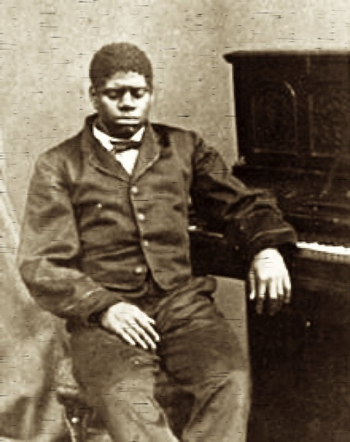[Frances Woolfolk Wallace](http://docsouth.unc.edu/imls/wallace/wallace.html) was a Kentucky woman from a “hot” Southern family who supported the Confederacy. In March 1864, she left her Kentucky home in search of her husband—a captain in General Bragg’s rebel army.

Two months later in Tuskegee, Alabama, she crossed paths with Blind Tom and his slave master, General James Bethune. On that day would spend much time in their company and recorded her impressions in her diary. At the time, Blind Tom was 15.

*May 18, l864:*

*When the stage arrived “Blind Tom” was on it. He is certainly one of the greatest wonders of the day, indeed the greatest. His memory is wonderful, his powers for imitating equally so and his musical talent surpasses anything I ever heard or dreamed of. We went to his concert tonight. He played the most difficult pieces, composed and arranged beautifully.*

Blind Tom in 1866, aged 17

*His imitation of “Old Uncle Charlie of Kentucky” was very good, and he repeated word for word as he heard Uncle Charlie speak. His piece called “Manassas Battle,” his conception of a battle from hearing the newspapers read, was splendid. Has imitations playing of the organ, guitar, banjo and violin, etc. After we returned home he came into our part of the hotel and we sang for him and he seemed pleased. Most of the time when he heard no music he was turning around like a top, a very singular person.*

*May 19, 1864:*

*We are invited this morning to Mrs. Conley's and have to accept as we declined last evening. We are sorry we cannot hear “Blind Tom” again.*

Blind Tom was also spotted in East Tennessee by Confederate officer named Major Philip H. Wallace, who was part of General Bragg's Kentucky's abortive campaign. He entered a memo into Mrs Wallace's diary, although part of the entry is missing.

*June 24 & 25, 1843:*

*On the 28th of June I was also in a fight between our division and Negley's division of the enemy at Bethpage Bridge on Elk River this side of Tullahoma and narrowly escaped being killed by a shell....(missing section) bringing two violins, a flute, and guitar. Blind Tom played on the violin and guitar, and we had some fine music.*

Confederate Brigadier General Mathew Ector from the Army of Mississippi was cut off from the eastern front and making his way back through Mississippi to rejoin his division when he came across Blind Tom and General Bethune at Lauderdale Springs—a once fashionable health resort in east Mississippi that, in 1864, was a hospital for sick and wounded soldier.

In a letter to her son sixty years later, Eliza Smith, owner of the only piano in Lauderdale Springs, recalled how Blind Tom entertained the officers and their troops at her home. She best remembered Blind Tom's impersonations of a debate in congress he had seen during a visit to Washington in 1859.