BIOGRAPHY
On a recent wintry afternoon in Manhattan, Stephan Crump was doing what he has done countless times in the city—toting his upright bass, clad in a heavy black bag, along the sidewalk, as if he had a baby that was also a bear.
Finding his car, Crump shimmied the instrument through the minivan’s side, climbed into the front seat, exhaled, and then grinned. In less than 24 hours, he would fly to Portland to teach “On Magnetism,” a long-accreting class on connecting more deeply with yourself and others through your instrument, and to play solo at the city’s jazz festival. But he knew he first needed to make the 40-minute trek from Brooklyn to Finlay + Gage, the legendary bass shop in Tribeca, to have his bass adjusted, so that he could make that connection himself. The sound post—that stout wooden dowel inside the bass that keeps it from collapsing on itself, and that the French call l’âme, or the soul—wasn’t sitting quite right.
“It’s so personal, elusive, and mysterious. Yes, it’s a mechanical thing, but it has so much mojo to it. That’s why it’s called ‘the soul,’” Crump explained several days later from Portland, noting that the hassle of the errand had been worth it. The bass felt good in his hands again. “It’s this combination of sound and feel.”
For a quarter-century now, pairing sound and feel have become Crump’s ambit and expertise. A bassist and composer, collaborator and bandleader, Crump has become one of New York’s most steadfast and experienced instrumentalists. He was the anchor of Vijay Iyer’s foundational trio for 20 years, even as he developed a slew of imaginative ensembles of his own—the two-guitar Rosetta Trio, the Borderlands Trio alongside Kris Davis and Eric McPherson, the Secret Keeper duo with Mary Halvorson, just to sample. In all of these contexts, the act of bringing the rest of his life to the bass—the trauma and hope, the frustration and delight—remains Crump’s primary motivation. It is, if you will, the soul of his playing.
“All art is an expression of the artist’s presence in that moment. Musicians need our evolving physical capabilities on the instrument and technical knowledge—how notes interact harmonically and melodically, transcribing our heroes, learning all that,” Crump said. “But in the act of making music, we need to allow that stuff to fall away, to not impose it on the music, to relinquish our defenses. We are sculpting energy as we make music, shaping magnetism.”

In some ways, Crump’s career is the fulfillment of his father’s own youthful ambition. His dad toyed with turning pro as a jazz drummer, but he pursued architecture instead. (That’s also how he met Crump’s mother, who comes from a long line of French architects.) His devotion to jazz, though, didn’t waver, and he would constantly play jazz classics—Monk, Miles, Coltrane, MJQ—in the family’s Memphis home. Crump thinks that’s where he fell for the bass, especially when the low-end would creep through old wooden walls at night. At his mother’s behest, though, Crump’s training started with piano, the Suzuki Method leading him through the classics and eventually to his all-time musical hero, Stevie Wonder.
But at 13, Crump finally got his first bass, a MapleGlo Rickenbacker 4001 like that of another hero, Yes’ Chris Squire. He joined a crackling power trio with his brother, later enlisted in a larger band, and then started his own group; they all gigged hard. Backpacking through Spain by himself after high school, however, he encountered an epiphany by the name of Dave Holland, playing in his mighty and future-facing quartet. The upright bass: That was Crump’s future.
His first was a dilapidated plywood model, collecting dust in a corner of Amherst College, where he’d in part gone to escape family turmoil down south. He’d intended to study physics and music, but he soon realized that his energy and enthusiasm belonged with the latter. That was helped along by a guitarist pal Crump met during his first few weeks at Amherst. He had connections in the West Village. Crump had the car. (“The bassist,” he half-joked, “always has the car.”) Most every week, they would drive the four hours south, link with high-caliber New York pros they’d hired, play until 2 a.m. or so, and head back to school.
“That was really powerful and clarifying. It was thrilling to be 18 and gigging in New York. I got a taste for that level of musicianship, and I was doing more than just cutting it,” he said, smiling. “By the end of my first semester, I knew I was moving to New York as soon as I graduated.”
That is precisely what Crump did. He used his paycheck from a month-long, fresh-out-of-college stint with the Tommy Dorsey Orchestra to rent his first Brooklyn apartment in 1994. He dove right in, roving the West Village with his bass, listening, and joining late-night jams that ended with the sun’s arrival. He’d seal his shades with tape, sleep, and repeat.
Crump, though, bristled at the scene’s pervasive machismo, how some of the city’s most vaunted players would put up walls to prevent revealing too much of themselves through their music. That’s actually what he craved. Crump found others who shared his ardor, earnestness, and a belief in what jazz could show of and to a person. Those people, like saxophonists Chris Cheek and Miguel Zenón, helped shape his first albums. There was film score work and sessions and stages alongside singer-songwriters. In these concentric creative circles, he met a young singer, Jen Chapin, and fell in love. They got married in September 1999.
After five years, the existence Crump had imagined for himself as a New York musician was happening. “My goal from the start was to come to New York and make a life in music—to make music that I loved, to learn and grow with amazing musicians,” said Crump. “I never set out to be a rock star, a jazz star. I just wanted to make music—real, deep, honest shit, you know?”
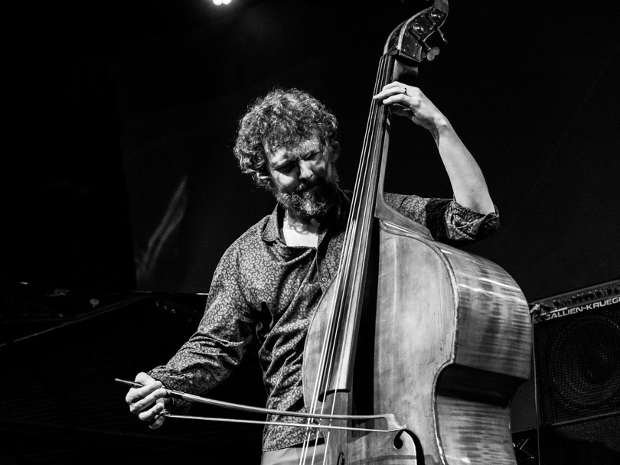
at Wels Unlimited Festival - photo by Peter Gannushkin

Actually, Crump flirted with something at least like “jazz stardom” during a 20-year stint in Vijay Iyer’s trio. Iyer cold-called Crump soon after moving to New York in 1999, on a friend’s recommendation. They spent the next 20 years building the band into one of modern jazz’s most successful units. It was a tremendous trip, of course, but it was again clarifying for Crump, revealing the sorts of bands he wanted to build outside of the Iyer orbit. He steadily realized that traditional jazz ensembles were not his preferred vehicle. The bass could get lost, its role restricted. And the power dynamics with such a clear and visible leader created an environment of dominance (again, often masculine) that he hoped to avoid.
“Control and bravado keep you from deeper layers of experience and expression,” he said. “When you find yourself with a group of people who are willing to at least attempt ego dissolution and real communion, you have the opportunity for transcendence. You open a portal for each other and the audience—that’s a service to society.”
Crump has found those connections in so many contexts, emptying his feelings into his diverse ensembles. Rosetta Trio’s bittersweet groove, for instance, emerged from little Fender Rhodes fragments he compiled in the months after watching 9/11 unfold with Jen from their Brooklyn roof. Open Wide, his 2002 set of duets with her, are intimate and entangled portraits of marriage’s first few difficult, delightful years.
The music of Rhombal—his celebrated quartet with Tyshawn Sorey, Adam O’Farrill, Ellery Eskelin—unfolded after the death of his brother, Patrick, the one who first brought him into a band back in Memphis. And Slow Water, his latest project built with a drum-less sextet of fascinating New York artists, hinges on the Memphis native’s experiences with bodies of water around the world, his lifelong love of nature, and his worry about and hope for our collective future.
“The acoustic bass is almost infinite as an instrument, sonically and expressively, but so much of that can get covered up in a traditional ensemble,” he said, turning toward his duos with saxophonist Steve Lehman and guitarist Mary Halvorson. “Those experiences gave me so much more room to explore the terrain of the instrument, its possibilities. That pushes you. It’s the kind of scary environment you want to put yourself in.”
When Crump talks about and teaches music, he doesn’t discuss notes. Or rather, they are only the beginning, the technical basis for something that can and should be something much richer. Notes are vessels that the player then fills with their experiences, their ideas, their emotions, their essence.
These are gestures, at least as he has put it for many years now, the basis of the music he wants to put into and get out of the world. In some significant ways, this echoes his childhood in Memphis, where his Southern grandmother instilled the value of a story well told, and where he worked alongside his uncle building furniture—really, sculptures of wood—that they would sand until the material seemed somehow to shimmer. (Crump’s music stand was made by his uncle, Stephen.) It wasn’t just an object or a story; it was a piece of work you invested yourself in until it became art.
“A note is an abstract notion, meaningless without all of the human, spiritual stuff you can channel into it,” Crump said. “A gesture has the physical element, a sense of offering, a reflection of our presence through each unfolding moment.”

