COOK OF THE WEEK: Nurse takes a nod from mother when it comes to cooking
by Ginna Parsons/NEMS Daily Journal

Scarlett Thompson of Hatley says when she makes this New Orleans Shrimp Salad to take to parties, there's never any left.

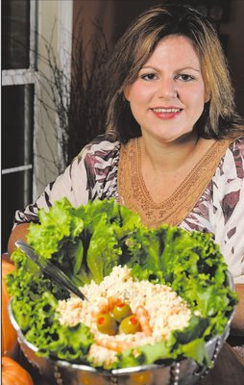
Scarlett Thompson is definitely her mother’s child. When Thompson and her sister, Melody, were growing up in Hatley, they were blessed to be in a home where food took center stage.

“My mother showed her love with food,” said Thompson, 34. “If anybody was in the hospital, under the weather, had just had a baby, you knew she was going to be there with food. She used the gift she had in such a positive way. And it wasn’t just her. My sister and I were a part of it, making the food and delivering it.”

Today, she shows her love for family and friends the same way.

“I love to cook. I really do. I love the way it looks. I love to see the way it’s presented,” said Thompson, a registered nurse at Pioneer Family Medical-Amory. Before that, she spent 12 years at the Family Medicine Clinic in Amory.

“When I was at FMC, every year my gift to the office staff was to prepare a sit-down dinner and serve them,” she said. “One year I made chicken and dressing, green beans, sweet potatoes and cheesecake. Another time we had baked lasagna, salad, green bean bundles and cheesecake. I always have to make cheesecake.”

Thompson cooks five nights a week for her family, which includes her husband, Kyle, and her children, Emma Rose and Clay.

“When I was growing up, when supper was ready, we were all at the table,” she said. “Not in the living room on a TV tray, not in our bedrooms. At the table together every night. Now, we do that here. We sit down and eat together. Mealtime is family time.”

In order to accommodate her busy schedule as a nurse, Thompson finds it helpful to cook ahead and in large quantities.

“On Sundays, I cook for Monday and Tuesday night. Wednesday is sandwich night. Thursday is my late night at the clinic, so my husband cooks if my mom doesn’t. We grill out on Friday nights, eat out on Saturdays and cook out on Sundays. And I rarely make just one of something. If I’m going to make meatloaf, I make two. If I’m making mac and cheese, I make two pans. That way we have one to eat and one for the freezer or for someone in the hospital or whatever.”

Thompson credits her mother, Sharon Hathcock of Hatley, with teaching her everything she knows about cooking. But she admits that she changes things up a bit these days.

“It’s funny how my recipes came from her, but I sort of veered off,” she said. “She’ll fry pork chops on the bone and fix biscuits. I’ll roll my boneless pork chops in crushed croutons and bake them. I’ve just taken her food and transitioned it to things that are easier for me to make.”

