My First Day in Mississippi’s Parchman Prison

Sometime between the end of 1950 and the summer of 1952, between my fourth and sixth birthday, I was taken to Parchman Prison, also known as Parchman Farm, which is twenty-eight miles northeast of Cleveland in the Mississippi Delta. And no, I was taken there not as punishment for refusing to eating my vegetables but because my grandfather, Charles Kirk Avent I, was one of three commissioners on the Mississippi Penitentiary Board.

Grandfather took my mother, my brother Kirk and me from Coldwater, grandfather’s home, to Parchman which was a distance of 72 miles. In those days that probably took two and half hours by car.

The only memory I have of this visit is one of my first memories. And why you ask, was it so memorable? Well, it was my doing, not intentional of course, I being such a young tyke. But nevertheless, there was consternation, anguish, panic, furious scurrying, pandemonium, and the cause for my suddenly being snatched up and rushed to the car.

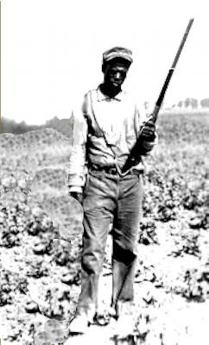
So, why? Well it seems we had stopped and got out of the car close to a work gang that was being guarded by a trustee who was armed with a rifle. At some point, it seemed I had walked away from our group and managed to get between the trustee and the members of the work gang. The only part of the incidebt I do remember, the whole storey relayed to me by my mother, is being snatched up suddenly and taken the the car. I am sure my name is imprinted in the history of Parchman Prison to this day.

