Kindness Helps Breast Cancer Survivor Fight for Her Life Goal
By RAY VAN DUSEN Monroe Journal
October 31, 2019

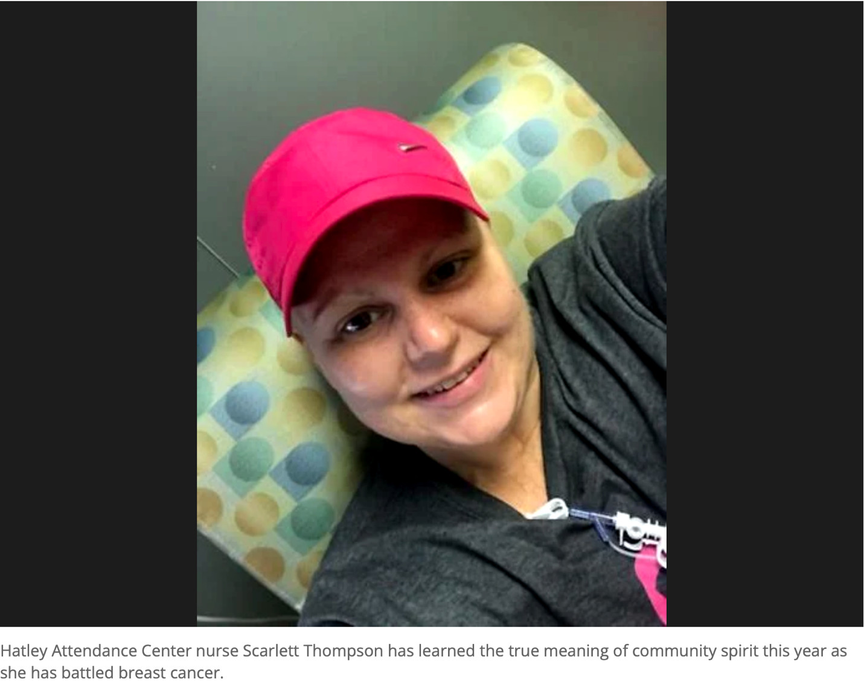

HATLEY – Two words that ring out more than others in Scarlett Thompson’s vocabulary are “Kindness Matters.” That phrase she saw on a bumper sticker while in the car line dropping off her children at Hatley years ago was one she kept sealed in the back of her mind.
It has revealed its true meaning this year as Thompson has fought triple negative breast cancer as Monroe County has rallied behind her in its shadow. Teachers throughout the Monroe County School District she hasn’t even met have donated time to ensure she hasn’t missed a paycheck, a gun raffle netted $7,000 to provide for her insurance deductible for chemotherapy, and people signed up to provide for enough meals to feed her family from her Feb. 12 surgery until the end of May.
“I told my kids to be kind to someone today,” she said of that day in the car line. “I never understood it until I was going through this.”
Her main goal throughout her fight has been simple – to see her children grow up.
Her diagnosis, her fight
Thompson did a self-breast examination and found a lump, and her platform to other women is the importance of self examinations.
“As a nurse, I never practiced what I preached. ‘I can’t tell because I’ve got so many lumps and bumps.’ That was my scapegoat too. I can tell women, now, they’ll know. If you do them monthly, you’ll know your body,” Thompson said.
After having a mammogram at North Mississippi Medical Center Gilmore-Amory, she had already received a call by the time she made it to the four-way stop in Hatley that she needed to undergo surgery. Within 24 hours, she met with a surgeon and had a biopsy.
“The surgeon said, ‘If they say it’s negative, I’ll biopsy it again because they’re wrong.’” At that moment, I knew it was real and I began to mentally prepare myself,” Thompson said.
Triple breast cancer is a rare form of the disease that infects 15 to 20 percent of breast cancer patients.
According to the National Breast Cancer Foundation, estrogen, progesterone and the HER-2 gene, which are the three most common types of receptors fueling most breast cancer growth, aren’t present in the cancer tumor, meaning breast cancer cells have tested negative for the three receptors.
Thompson said triple negative breast cancer is more aggressive than other types of the disease.
She underwent a bilateral mastectomy, and her recovery wasn’t easy, which resulted in a prolonged start of her chemotherapy. She never went to a single treatment without a family member with her, and her mother was always by her side. On the days she went for chemo, the text messages of support started at 5 or 6 in the morning.
Thompson found a personal connection with a female oncologist, Dr. Amber Borden, at Baptist Memorial Hospital-Golden Triangle.
“She’s a mother of three, and there’s no love like a mother’s love, except for His love. I told her my goal is to see my children grow up, and she understood what I meant. Everyone wants to survive but as a mother, it’s imperative,” Thompson said. “Women need to understand they need to find someone they’re comfortable with and not just someone who can get you in the quickest or someone your friend goes to.”
Her community, her home
Thompson worked for 15 years at Dr. Clint Washington’s family practice before accepting the offer as Hatley Attendance Center’s nurse four years ago. Her parents, Mike and Sharon Hathcock, retired from the school after 21 and 20 years, respectively, and are still, in their 70s, involved with substitute teaching and coaching paraprofessionally for free.
Thompson is a 1996 Hatley High School alumni and she never realized the enormity of not just the school, the town and the whole county until battling breast cancer.
“The Monroe County community is unlike any other. I didn’t have a clue until it was me who received all the kindness,” she said. “My mom always said Hatley is the best school on Earth. I never knew what she meant until I got sick. Hatley school has done more for me than I could ever repay. The teachers at Hatley treated my kids like they were their own. I vowed whenever I beat this, I’d do the same for someone else.”
In addition to her Hatley co-workers, faculty and staff from Hamilton and Smithville attendance centers donated time for Thompson. Basketball players wore pink socks in honor of her, and bracelets were sold in support of her.
The slogan on T-shirts and bracelets associated with her fight was “I Will Win,” which goes back to her competitive spirit.
Even her neighbors rallied behind her through meals, money, balloons on her mailbox and pink ribbons on every mailbox to illustrate their support.
Thompson encourages other women battling breast cancer to face it, draw their strengths and surround themselves with a strong support system.
“I think you pay it forward. My mom and dad paved the way for me. They taught me that your reap what you sow. I think sometimes in life you get so busy and we need to see a bumper sticker. I’ve always thought I knew what [Kindness Matters] meant. Kindness truly, truly changed my perception of the disease. We truly have the best community.
“There were days I thought I couldn’t fight but there were always days when someone told me I could. Not everything about cancer is bad. I’m a better person because of it,” Thompson said.

