GSDP ANNOUNCES ANNUAL AWARD WINNERS, RELEASES ANNUAL IMPACT REPORT
STARKVILLE, Miss.—The Greater Starkville Development Partnership recognized local businesses and individuals during its 2023 Annual Awards Banquet Tuesday night hosted at the Mill at MSU.
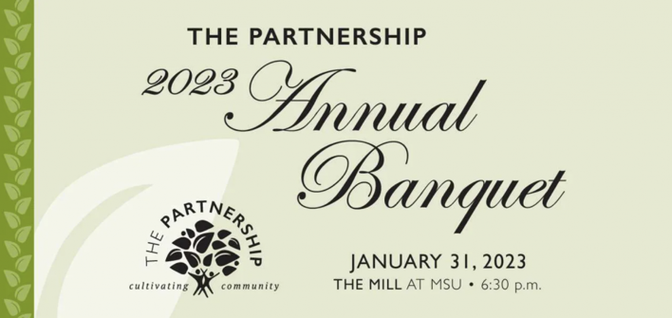
Chick-fil-A Starkville was honored as the R. Clay Simmons Exemplary Enterprise Award winner, recognized as Starkville’s most outstanding business for the previous year. After celebrating their tenth year of business in Starkville, Chick-fil-A continues their mission of serving the Starkville community. In addition to sponsoring events like Pumpkinpalooza and the Frostbite Half Marathon that draw thousands of people to Starkville, they also support education initiatives by providing lunch and leadership seminars to teachers and students at local schools and at Mississippi State University.
Robin Fant of Eat With Us Group was the recipient of the T.E. Veitch Community Service Award, and Bill Thurlow of Lazer 96.1/SuperTalk 100.9 was named the Partnership’s Ambassador of the Year.
The Oktibbeha County Economic Development Authority (OCEDA) named Garanas the Industry of the Year, and NFL player and former MSU Bulldog Jeffery Simmons took home the Convention and Visitors Bureau Crystal Pineapple Tourism Award for his impact on the tourism industry in Starkville through his football camps and investment in a new turf field at the Starkville Sportsplex.
The Starkville Main Street Association also named Mississippi State’s Pi Kappa Alpha Fraternity Partner of the Year for their volunteer efforts with logistics at local events.
The Partnership also released its 2022 annual impact report during the event, which highlighted the successes and growth of the Starkville business community.
The Partnership is comprised of the Starkville Area Chamber of Commerce, Oktibbeha County Economic Development Authority, Starkville Convention and Visitors Bureau and the Starkville Main Street Association.

